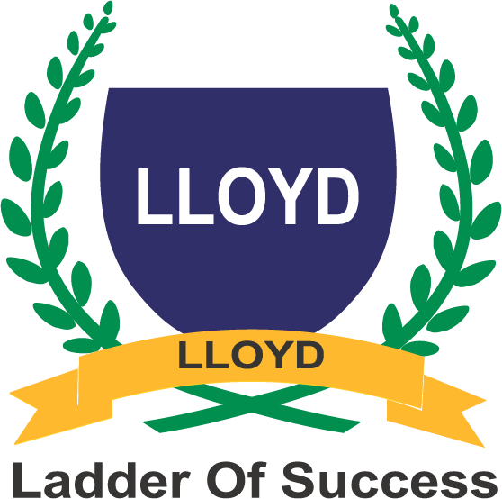
LLOYD INSTITUTE OF ENGINEERING & TECHNOLOGY
(Affiliated to Dr. A.P.J. Abdul Kalam Technical University & Approved by AICTE, New Delhi) Plot No. 3, Knowledge Park II, Greater Noida, Uttar Pradesh – 201306

DEPARTMENT OF COMPUTER SCIENCE & ENGINEERING & ALLIED BRANCHES

MINI PROJECT (BCC351/BCS554 /BCS752)

Weekly Progress Log Format (for Students)

Date | Work Done / Issues Faced | Mentor Remark & Sign
1 | Problem identification + initial study
2 | UCI dataset collection + field understanding
3 | Data cleaning + daily aggregation
4 | Exploratory Data Analysis
5 | Trend, seasonality, decomposition + ADF
6 | Chronological split + Naive baseline
7 | ARIMA implementation + evaluation
8 | SARIMA + model comparison + forecasting
9 | Streamlit dashboard + testing
10 | Report, PPT, final testing + viva

